A000-Indo-Sulawesi-Toraja-Water Buffalo Crypt Door-Wood-Mid 20th century

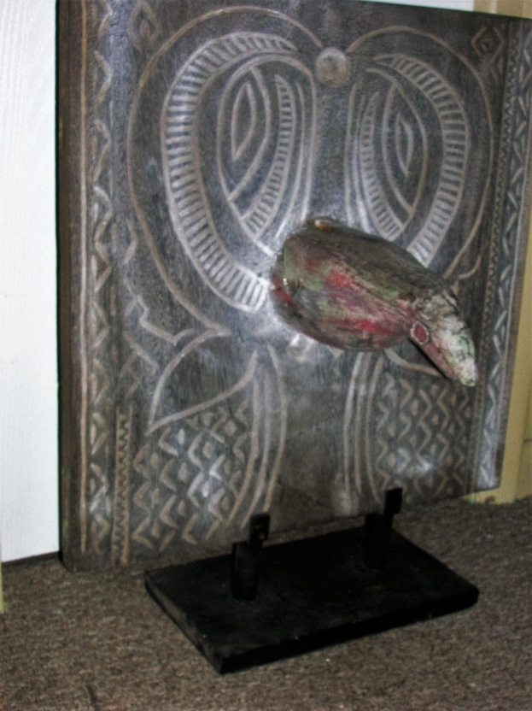

Fig. 1. Sulawesi-Toraja-Water Buffalo Crypt Door-Wood-Mid 20th century

**Case no.: Oceania**

**Accession Number: A000**

**Formal Label:** Sulawesi-Toraja-Water Buffalo Crypt Door-Wood-Mid 20th century

**Display Description:**

This Toraja Water Buffalo Crypt Door with the horns of the water buffalo pointing up and the head and a third horn also pointing down (to signify death) protruding from the forehead of the water buffalo (the source of its spirit). The chevron geometrics in black and white signify the purifying blood that issued forth from the sacrificial buffalo, which sanctified the spirits in the adjacent human tombs as well.

The next thing that has to be done is to prepare the Water Buffalo’s crypt door, which symbolically establishes a place of great sanctity next to the newly deceased person.

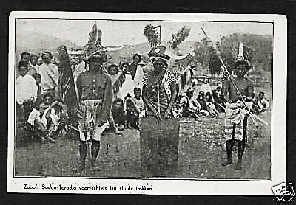

Fig. 2. Toraja of Rantepao of South Sulawesi, dressed with a traditional loin cloth and woven cap, which he would have worn in the traditional Water Buffalo Sacrifice Ceremony, in a postcard ca. 1920’s by Drukkerij van Lonkhuyzen of Zeis, Netherlands.

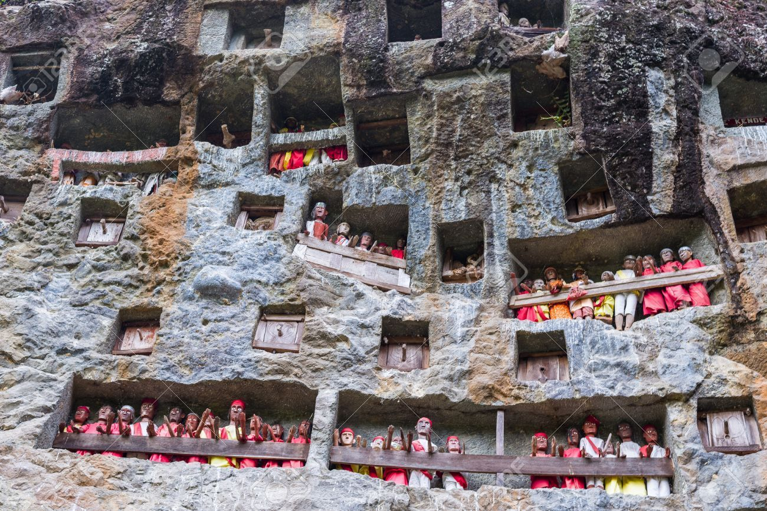

Fig. 3. Photograph showing the exquisite expanse of a white-washed limestone cliff wall at Londa Londa to keep the funeral remains of individual *liangs* or family groups and their tombs (*patanes*) and their *tau taus* or wooden effigies of the spirits of the dead safe from robbers. Above and to the right of these *tau taus* are Water Buffalo Crypt Doors with protruding water buffalo horns that act as sanctifying presences. After <http://i.ebayimg.com/images/g/s6UAAOSwbYZXVxUX/s-l400.jpg>

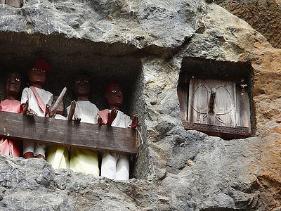

Fig. 4. Detail showing a *liang* and a group of tau *taus* (left) and a Water Buffalo Crypt Door (right) with one horn protruding as a handle. After <http://i.ebayimg.com/images/g/s6UAAOSwbYZXVxUX/s-l400.jpg>

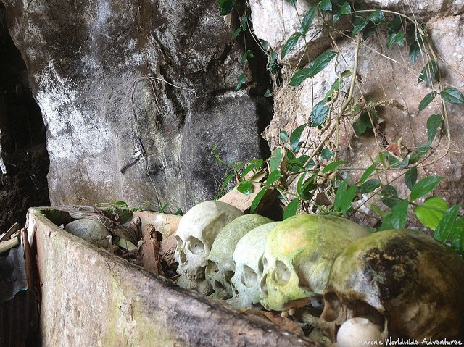

Fig. 5. The final destination of the deceased here he has been finally “walked to” along with his predecessors’ skulls and remains inside a burial cave or *patane* in Londa Londa.

Managing the spirits of the dead is an important matter for Torajans and much work goes into making each funeral a success. *Rambu Solo*’ is a ritual of escorting the corpse from *rante* charnel house to the tombor *patane*. The corpse is believed to be able to walk due to the prayers to the ancestors and their spirits so these remote *patanes* act as safeguards preventing spirits of the dead from wandering too far!

**LC Classification:** DS632.T7

**Date or Time Horizon:** mid 20th century

**Maps:**

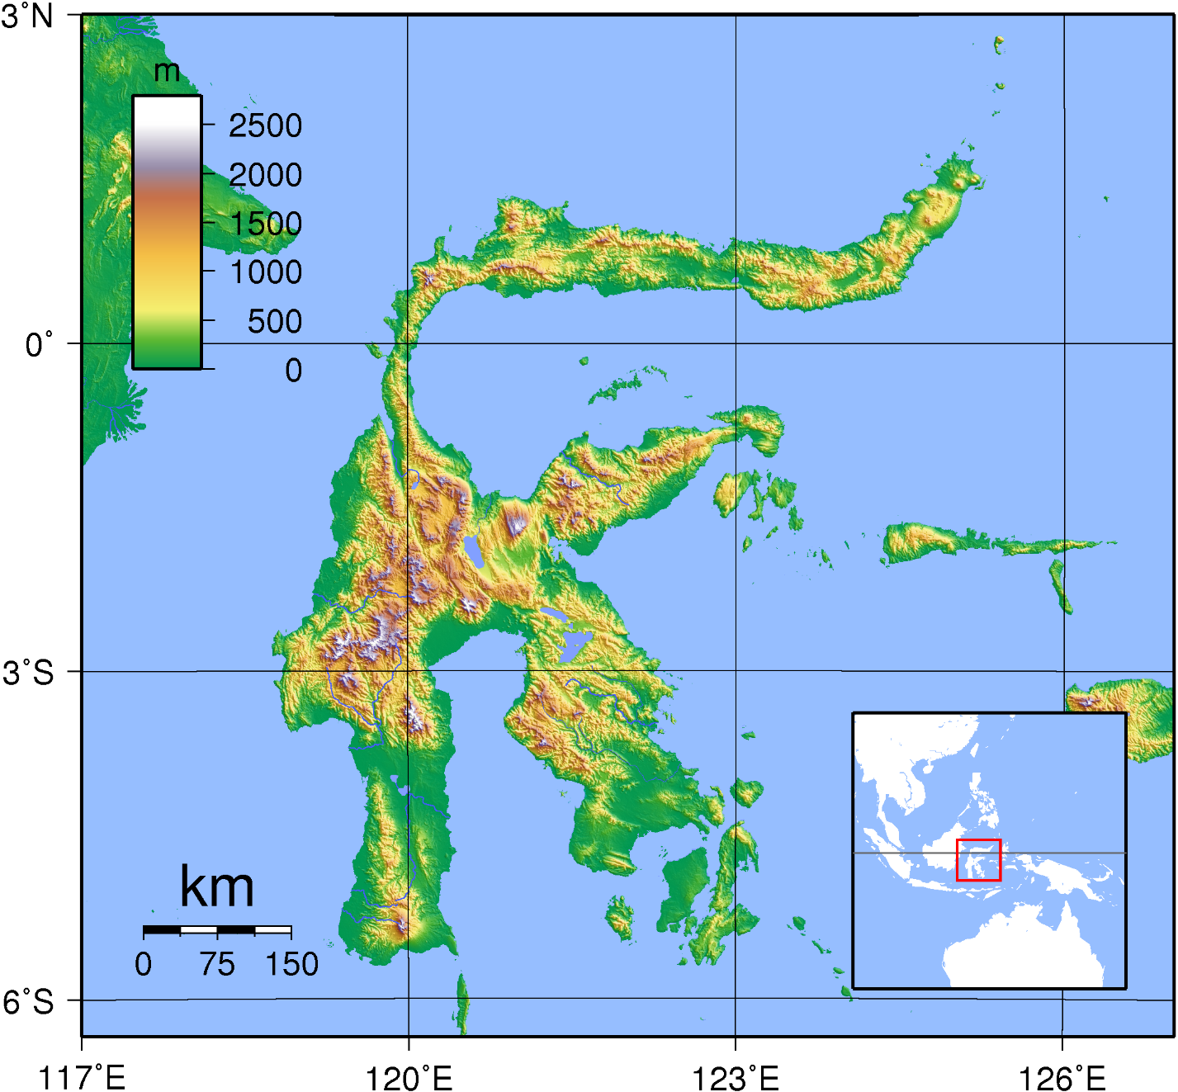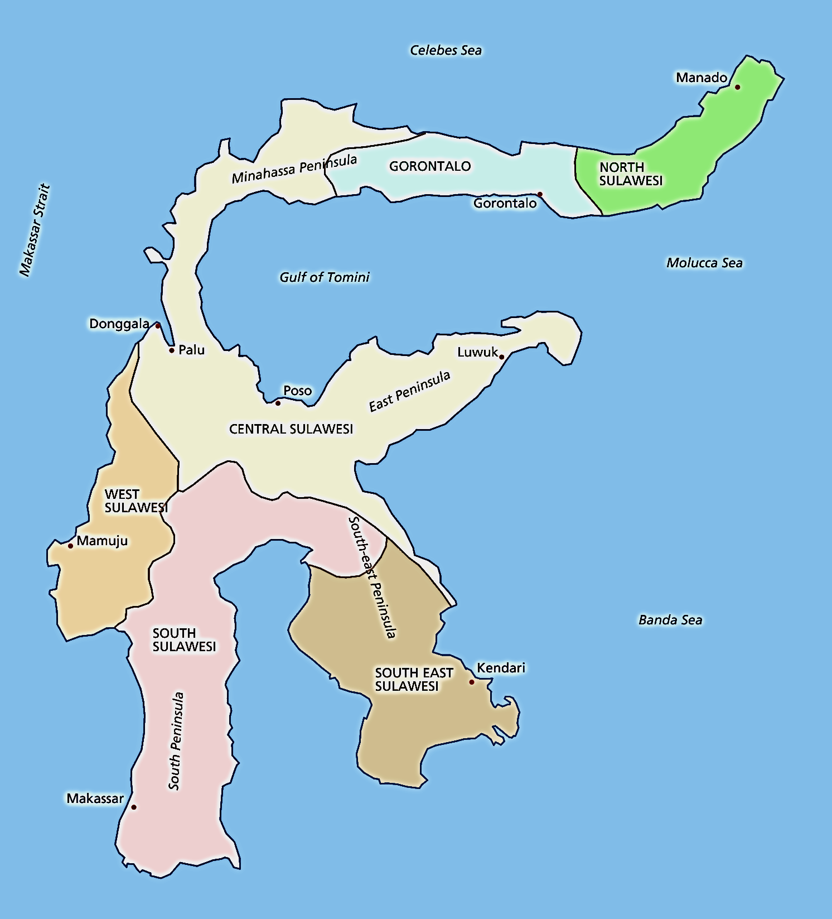

Figs 6-7. Maps of Sulawesi in Indonesia

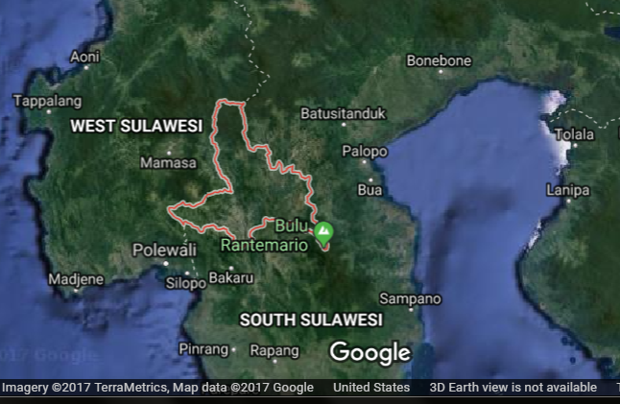

**Fig. 8. Map of South Sulawesi**

**GPS coordinates: -3°22'54.00" S 120°01'43.00" E**

**Cultural Affiliation:** Toraja, Sulawesi, Indonesia

**Medium:** wood.

**Dimensions:**

**Weight:**

**Condition: original**

**Provenance**: Robert Cornell Collection, New York

**Discussion:**

The Toraja, who live in Central and South Sulawesi, formerly known as the Celebes, speak an Austronesian, Malayo-Polynesian language and have an animist religion (Gordon 2005: 434). Their neighbors, the Bugis, are also an Austronesian-speaking people with an animist religion, Tolotang. Both groups had migrated to south Sulawesi around 2500 BCE from Taiwan after first emigrating from south China (Wen and Chen 2008). Thus, they were part of the Austronesian expansion that ultimately led to the Polynesian migrations into the Pacific islands. The Bugis call the Sa'dan-Toraja, To-ri-aja (To-ri-adja) that literally means “people from the interior” where there are many mountains up to 3,000 m high. So the Toraja are also considered mountain people. When the English arrived, they thought the Toraja’s name denoted a place “To” Raja”, but in Indonesian “raja” means "king" or "ruler,” so when the British referred to these people as people of raja they were in a sense called "people of high rank." To the Toraja, themselves, “raja” means “magnificent” or “handsome”. Thus, these three meanings of “Toraja” coalesce in referring to these people as “handsome people of high rank from the mountains”.

Although recent demographic figures are not available we do have the following statistics. There were about 325,000 Torajans (Nooy-Palm in Eliade 1987, Vol. 14, 565). In 1975 half of these practised Aluk To Dolo. Now this is estimated to be only 30 per cent. Of the remainder 60 per cent are Christian and 10 per cent Muslim (Dalton 1988, 845).

**References**

Adams, Kathleen M. 2006 *Art as Politics: Re-crafting Identities, Tourism and Power in Tana Toraja, Indonesia*. Honolulu: University of Hawaii Press.

Adams, Kathleen M. 1993. "Theologians. Tourists. and Thieves: The Torajan Effigy of the Dead in Modernizing Indonesia," *Kyoto Journal*, 22: 38–46.

Blanche, Patrick. 2011. ["The tau tau of the Toraja"](http://www.rawvision.com/rawvision/current/tautautorajas/tautautorajas.html). Raw Vision. Watford, Hertfordshire. https://rawvision.com/articles/tau-tau-toraja

Gordon, Raymond G., Jr, ed. 2005. *Ethnologue: Languages of the World*. 15th ed. Dallas: SIL International.

Li, H; Wen, B; Chen, SJ; et al. 2008. ["Paternal genetic affinity between Western Austronesians and Daic populations,"](http://www.ncbi.nlm.nih.gov/pmc/articles/PMC2408594/figure/F1/) Evolutionary Biology 8: 146.

Sammut, Jesmond. 2009. ["Tau tau gallery at Toraja burial site"](http://australianmuseum.net.au/image/Tau-tau-gallery-at-Toraja-burial-site/). The Australian Museum. <https://australianmuseum.net.au/image/tau-tau-gallery-at-toraja-burial-site>

Volkman, Toby Alice.1990. "Visions and Revisions: Toraja Culture and the Tourist Gaze," *American Ethnologist*, 17 (1): 91–110.